La Ratte Potatoes Information Pack
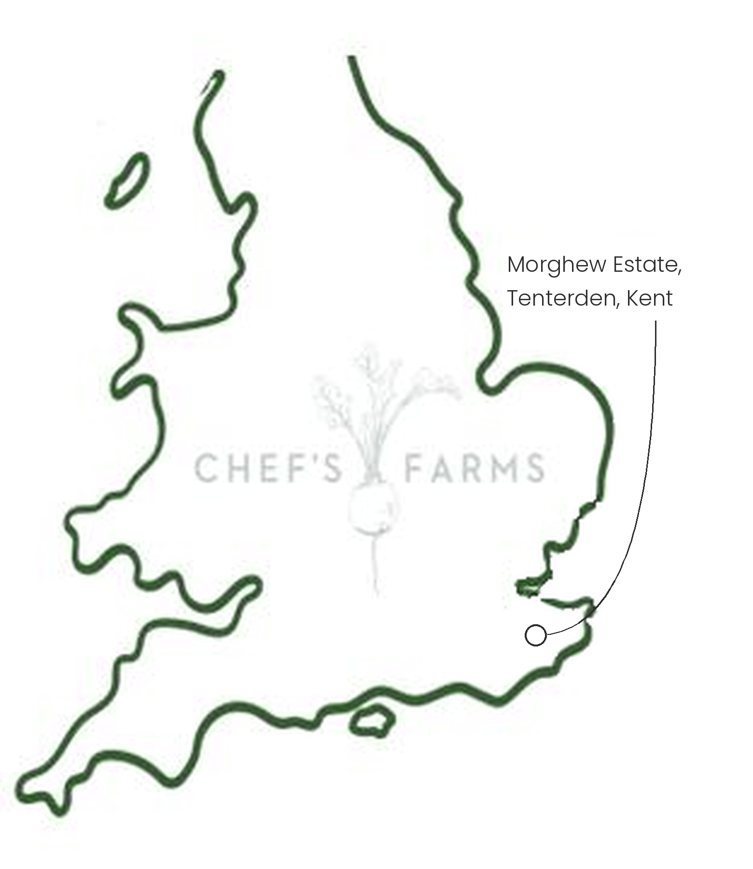
Introduction
La Ratte is a heritage French salad potato, small and knobbly, with a firm, waxy texture and a nutty, buttery flavour. It holds its shape perfectly when cooked, which has long made it a favourite with chefs.
Farm Information
Our La Ratte are grown by Luke and the team at Morghew Estate near Tenterden in Kent. Heritage potatoes are their speciality, and alongside La Ratte they grow Pink Fir Apple, Violetta, Vitelotte, Heide Red and Emmalie Red, as well as Charlotte and Wilja.
Heritage varieties like La Ratte yield far less than modern varieties and come out of the ground in all shapes and sizes, which is why so few growers bother with them. They are grown for flavour rather than volume, and that is exactly what makes them worth seeking out.
Potatoes need a long break between plantings to keep soil-borne pests such as potato cyst nematode at bay, so they are grown as part of a crop rotation. After lifting, the potatoes are stored cool and dark, so supply carries on well after harvest.
We are proud to work with Luke and the team.
More
La Ratte are lifted from late summer and stored through the autumn and winter. Cook them whole with the skin on: steam or boil, then crush with butter, dress warm for a potato salad, or roast until crisp.
Nutritionally, potatoes are a good source of vitamin C, potassium and vitamin B6, with most of the fibre found in the skin.
Media
See shared album

